

Name:

WAQAS ASHIQ

Roll No:

Fa11-Ciit-DDP-BCS-201

Section:

C

Submitted To:

Mam.Ayesha

* OBJECT ORIENTED PRORAMMING *

*ASSIGNMENT #.1 *

**EXERCISE:1**

**SOURCE CODE:**

import java.util.Scanner;

public class Lab_Assign1{

public static void main (String[] args) {

Scanner input= new Scanner(System.in);

int a,b,c,d;

System.out.println("Enter '1' to add numbers\nEnter '2' to subtract numbers\nEnter '3' to multiply numbers\nEnter '4' to divide numbers\nEnter '0' to end");

a=input.nextInt();

while(a!=0){

switch(a){

case 1:

System.out.println("Enter the first number");

b=input.nextInt();

System.out.println("Enter the second number");

c=input.nextInt();

d=b+c;

System.out.println("\nThe sum of two numbers is "+d);

System.out.println("Enter '1' to add numbers\nEnter '2' to subtract numbers\nEnter '3' to multiply numbers\nEnter '4' to divide numbers\nEnter '0' to end");

a=input.nextInt();

break;

case 2:

System.out.println("Enter the first number");

b=input.nextInt();

System.out.println("Enter the second number");

c=input.nextInt();

d=b-c;

System.out.println("\nThe difference of two numbers is "+d);

System.out.println("Enter '1' to add numbers\nEnter '2' to subtract numbers\nEnter '3' to multiply numbers\nEnter '4' to divide numbers\nEnter '0' to end");

a=input.nextInt();

break;

case 3:

System.out.println("Enter the first number");

b=input.nextInt();

System.out.println("Enter the second number");

c=input.nextInt();

d=b*c;

System.out.println("\nThe product of two numbers is "+d);

System.out.println("Enter '1' to add numbers\nEnter '2' to subtract numbers\nEnter '3' to multiply numbers\nEnter '4' to divide numbers\nEnter '0' to end");

a=input.nextInt();

break;

case 4:

System.out.println("Enter the first number");

b=input.nextInt();

System.out.println("Enter the second number");

c=input.nextInt();

d=b/c;

System.out.println("\nThe division of two numbers is "+d);

System.out.println("Enter '1' to add numbers\nEnter '2' to subtract numbers\nEnter '3' to multiply numbers\nEnter '4' to divide numbers\nEnter 0 to end");

a=input.nextInt();

break;

}

}

}

}

***OUTPUT:***

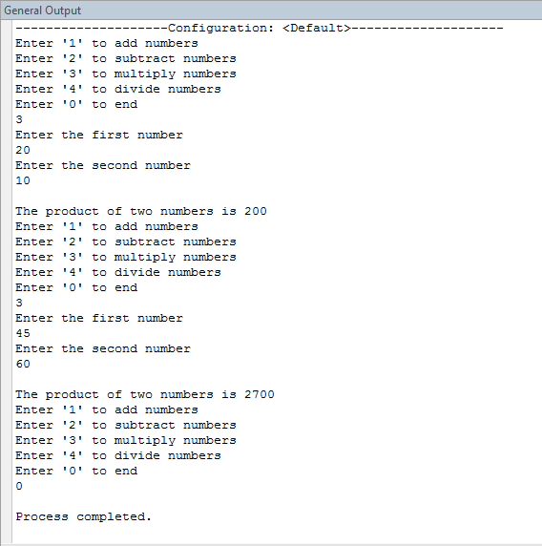

***EXERCISE:2***

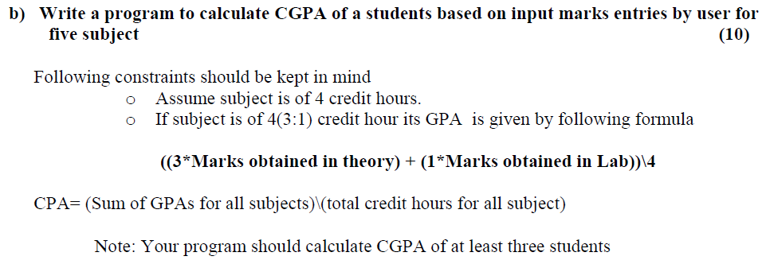

***SOURCE CODE:***

import java.util.Scanner;

class Lab_Assing1{

public static void main(String[]args){

Scanner input= new Scanner(System.in);

int count,Theo,Lab,GPA,CGPA;

int sum=0;

System.out.println("Enter 0 to end and 1 to continue the CGPA calculator");

count=input.nextInt();

while(count!= 0){

for(int x=0;x<5;x++){

System.out.println("Enter the marks obtained in Theory of subject");

Theo=input.nextInt();

System.out.println("Enter the marks obtained in Lab of subject");

Lab=input.nextInt();

GPA=((3*Theo)+(1*Lab))/4;

sum=sum+GPA;

}

CGPA=sum/20;

System.out.println("The CGPA of student is "+CGPA);

System.out.println("Enter 0 to end the CGPA calculator");

count=input.nextInt();

}

}

}

***OUT PUT:***

